FOCP ASSIGNMENT 1

MODULE 2
Ques 2
smallest multiple

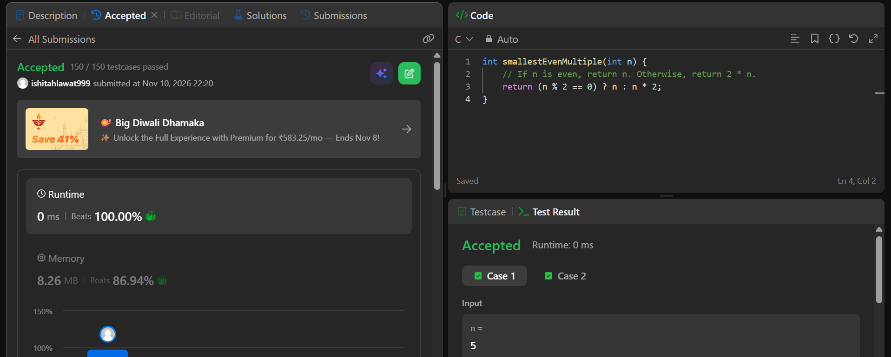

int smallestEvenMultiple(int n) {
// If n is even, return n. Otherwise, return 2 * n.
return (n % 2 == 0) ? n : n * 2;
}

